|  |  |
| --- | --- |
| **Name:** | **Dhuware Chaitanya Rakesh** |
| **Roll Number:** | **20IM10009** |

**1.Aim of the experiment:**

* Familiarisation with Signal Generator, Oscilloscope
* Studies on RC, CR and RL circuits

**2.Tools used:**

* **VS Labs**
* **Falstad**

**3.Background knowledge (brief):**

* **Voltage Divider (from Expt1)**
* A **voltage divider** is a simple circuit which turns a large voltage into a smaller one. Using just two series resistors and an input voltage, we can create an output voltage that is a fraction of the input. A voltage divider involves applying a voltage source across a series of two resistors.
* For a voltage divider: Vout = Vin(R2/R1+R2).
* In Thevenin’s equivalent circuit of the voltage divider, the voltage source is replaced by an equivalent Thevenin’s voltage and all the resistors are replaced by a single equivalent Thevenin’s resistance.
* **Voltage Divider (Expt2)**
* The main purpose of an oscilloscope is to **graph an electrical signal as it varies over time**. Most scopes produce a two-dimensional graph with **time on the x-axis** and **voltage on the y-axis**.
* Uses:

► Measurement of peak-to-peak voltage of a waveform

► Frequency of periodic signals and time between pulses

► Observing constant time varying signal voltages

► Shape of input/output signa ls in a circuit

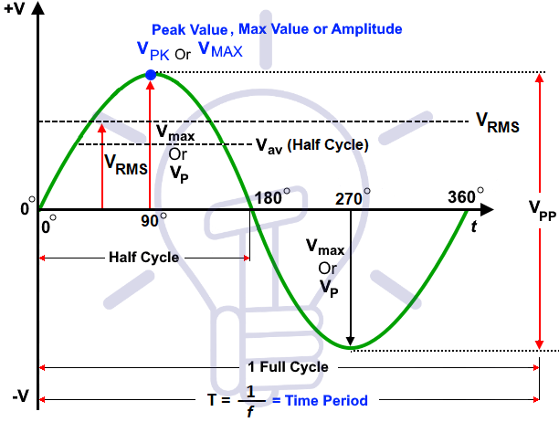

* **Frequency Response**
* **Frequency Response** of an electric or electronics circuit allows us to see exactly how the output gain (known as the magnitude response) and the phase (known as the phase response) changes at a particular single frequency, or over a whole range of different frequencies.
* The -3dB corner frequency points define the frequency at which the output gain is reduced to 70.71% of its maximum value. The -3dB point is also the frequency at which the systems gain has reduced to 0.707 of its maximum value. The -3dB point is also known as the half-power points since the output power at this corner frequencies will be half that of its maximum 0dB.
* Frequency Response of low pass RC/RL filter is nearly flat for low frequencies and all of the input signal is passed directly to the output, resulting in a gain of nearly 1, called unity, until it reaches its Cut-off Frequency point (fc). After this cut-off frequency point the response of the circuit decreases to zero at a slope of -20dB/ Decade or (-6dB/Octave) “roll-off”
* The Frequency Response Curve above for a passive high RC/RL pass filter is the exact opposite to that of a low pass filter. Here the signal is attenuated or damped at low frequencies with the output increasing at +20dB/Decade (6dB/Octave) until the frequency reaches the cut-off point (fc)
* The formula to find the frequency cut-off point of an RC circuit is, frequency= **fc** =1/2πRC.
* The formula to find the frequency cut-off point of an RC circuit is, frequency= **fc = R/(2πL)**
* **Pulse Response**
* pulse response refers **to the reaction of any dynamic system in response to some external change**.

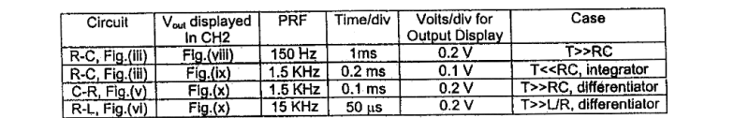The Following Setup is being made:

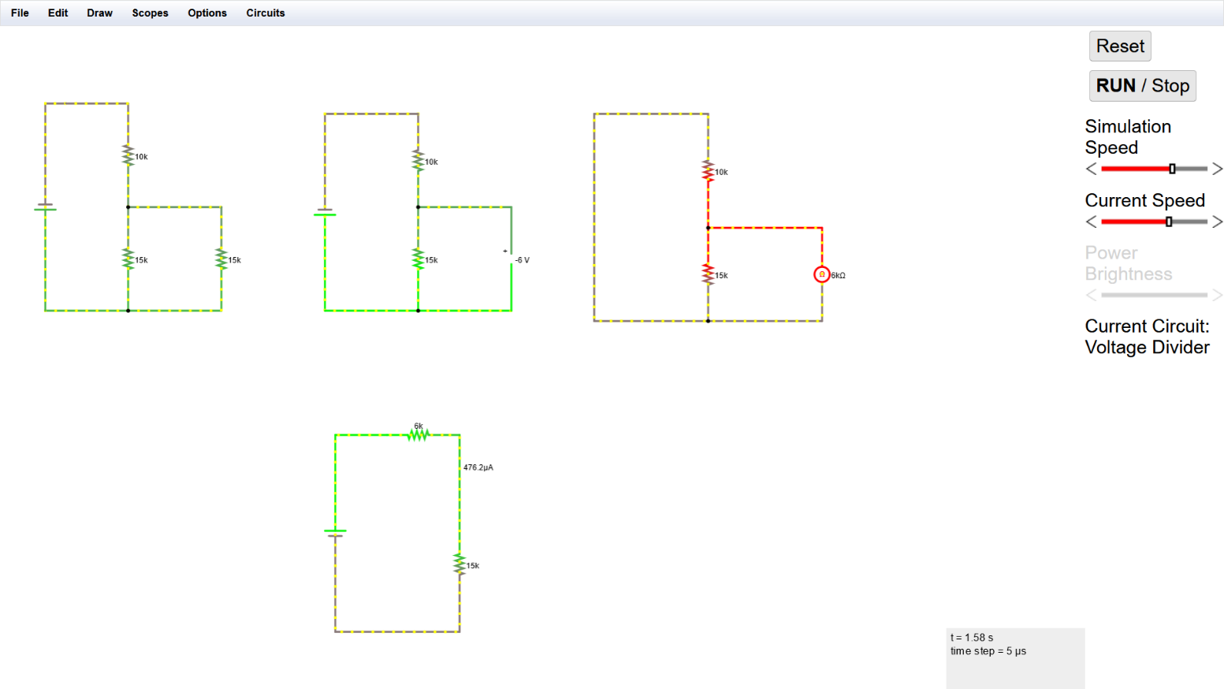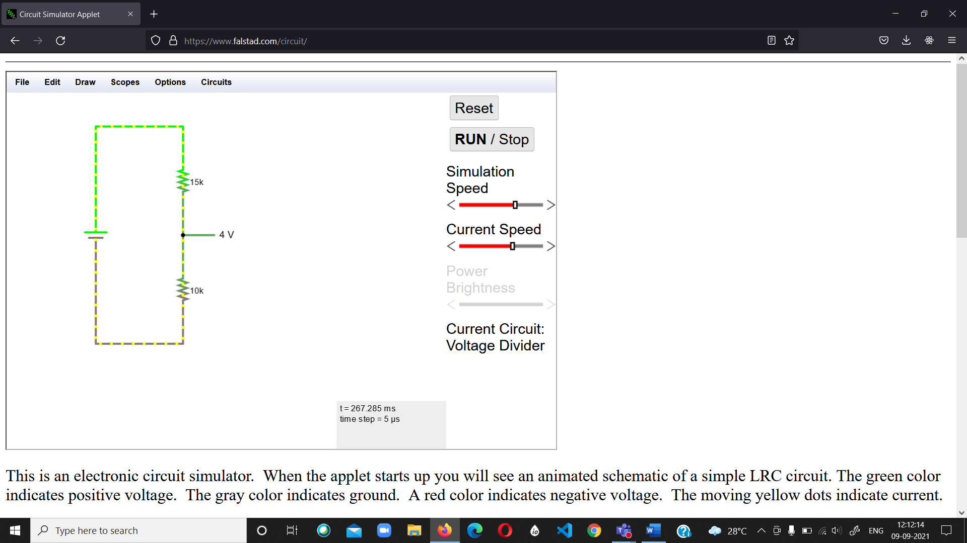**4.Circuit (hand drawn/image)**

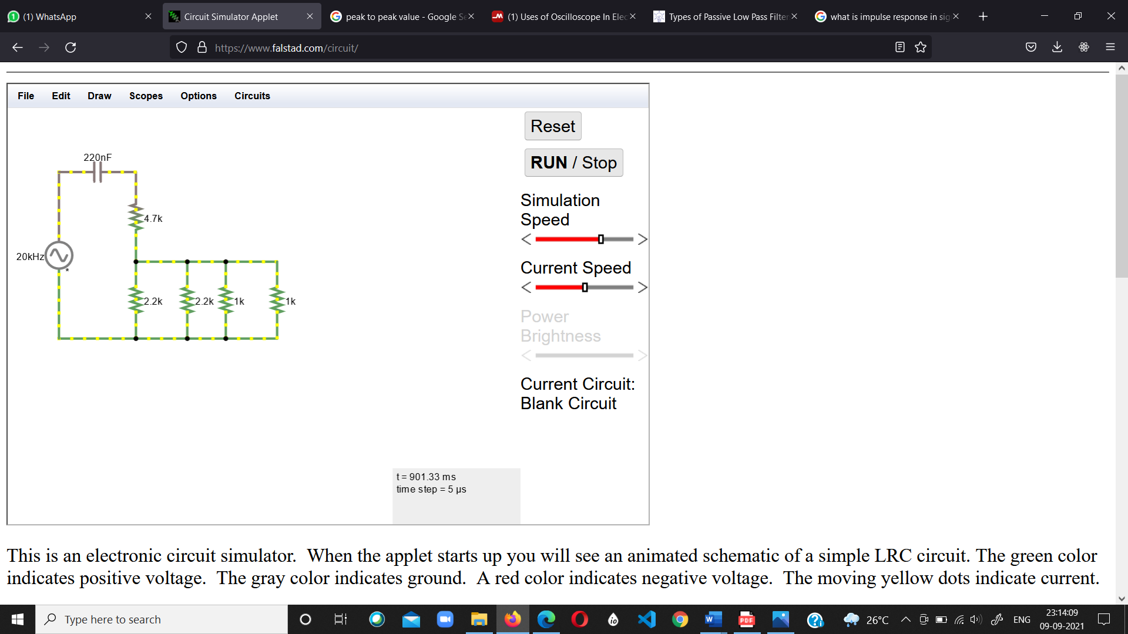

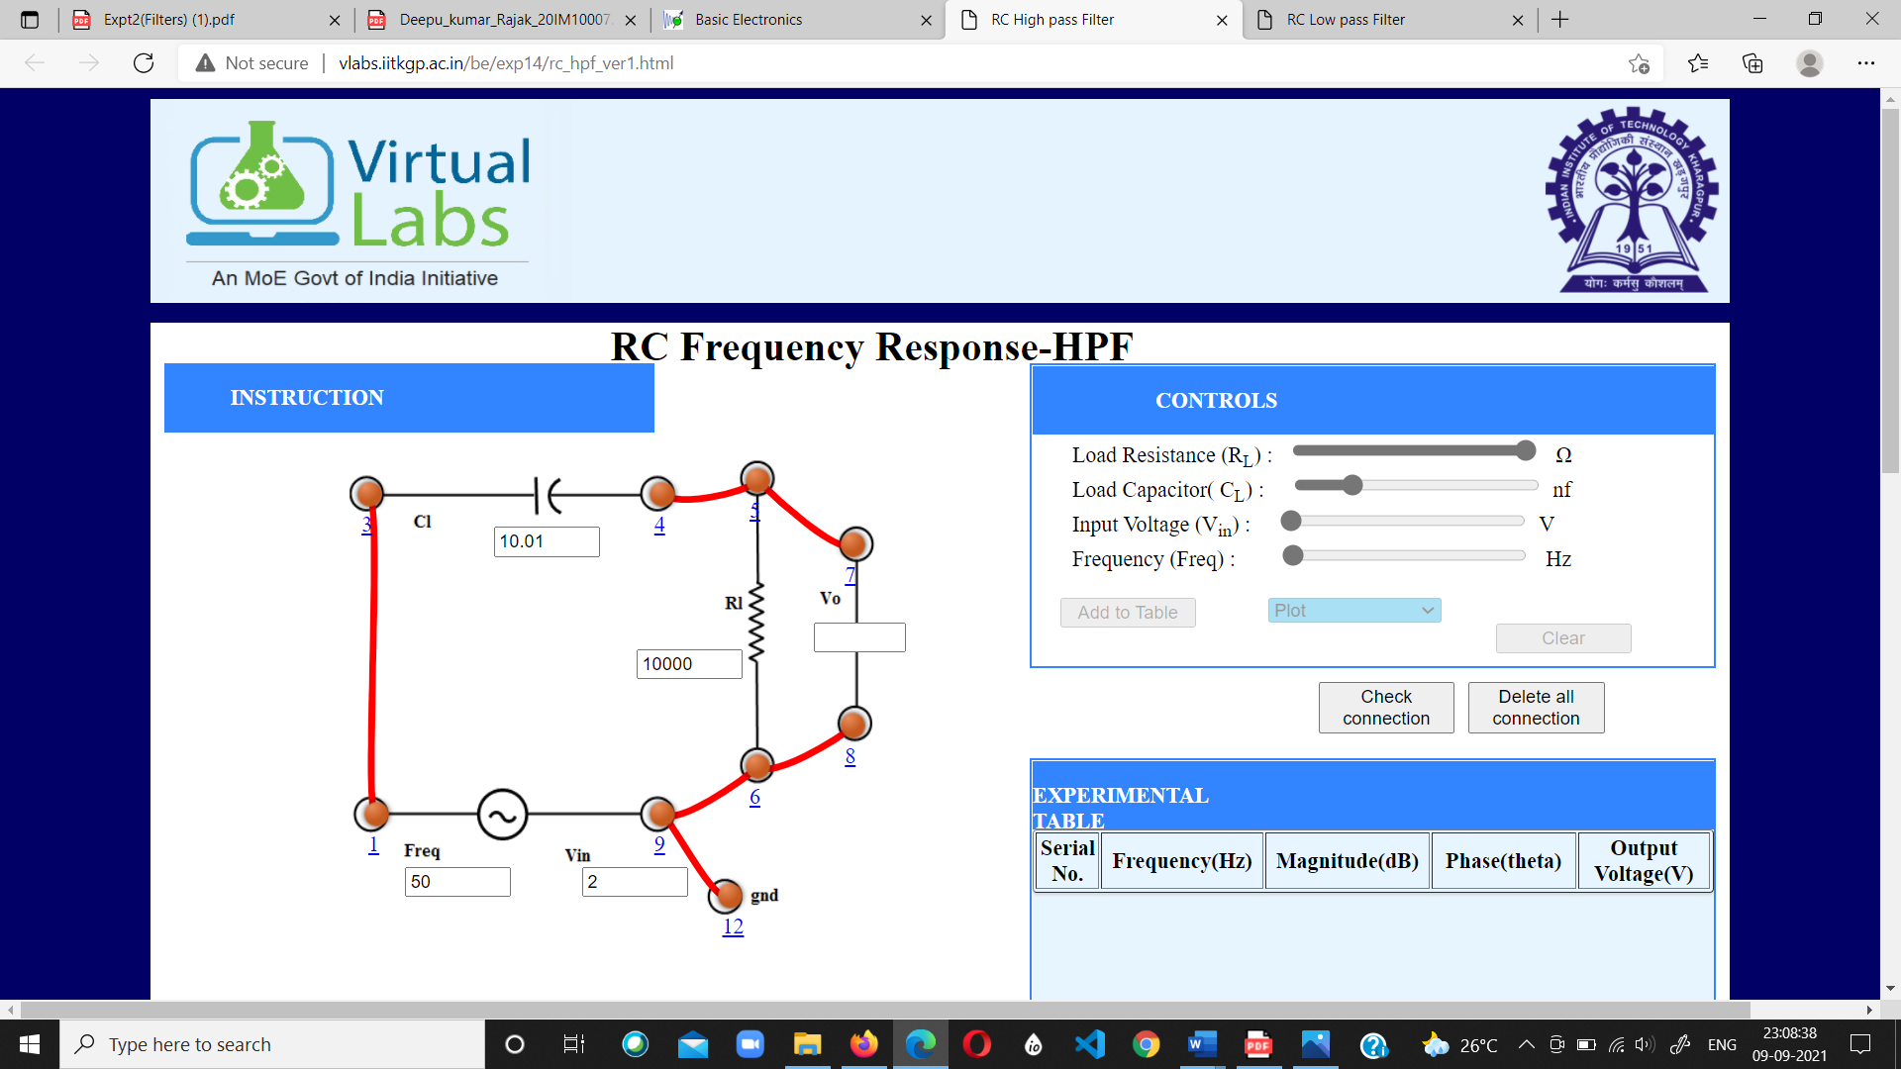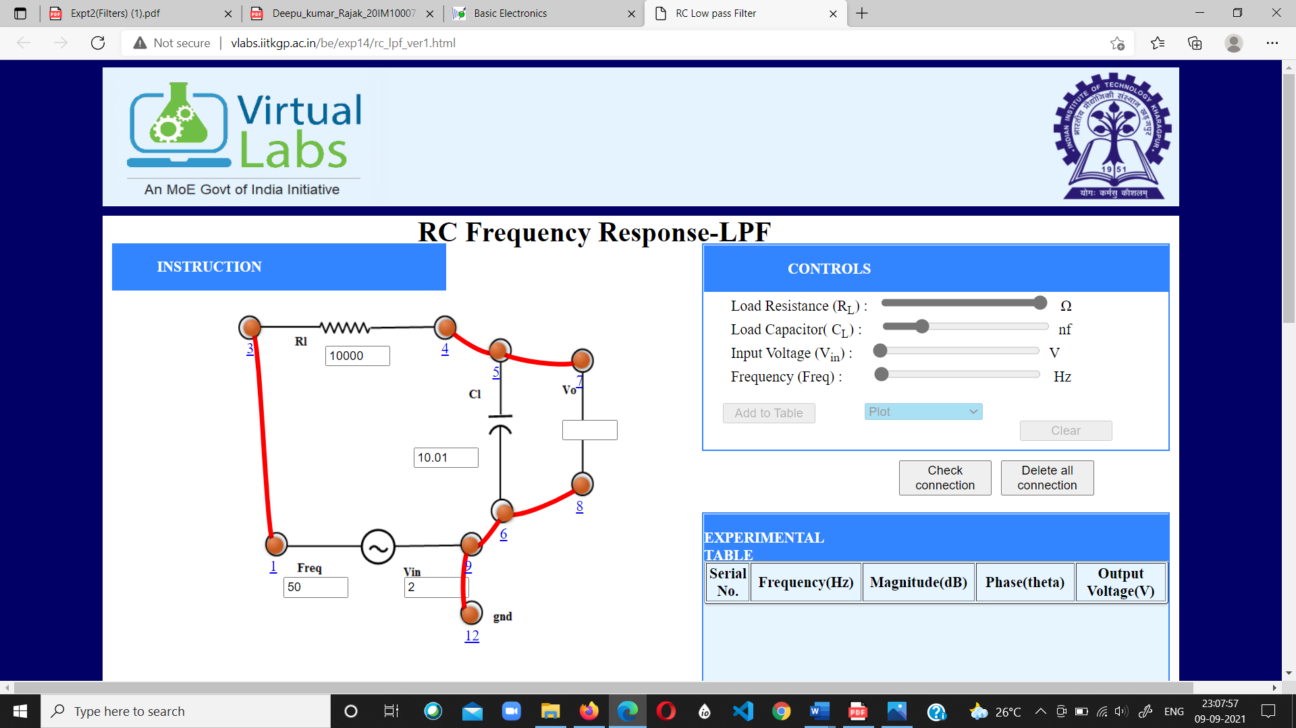

PULSE RESPONSE

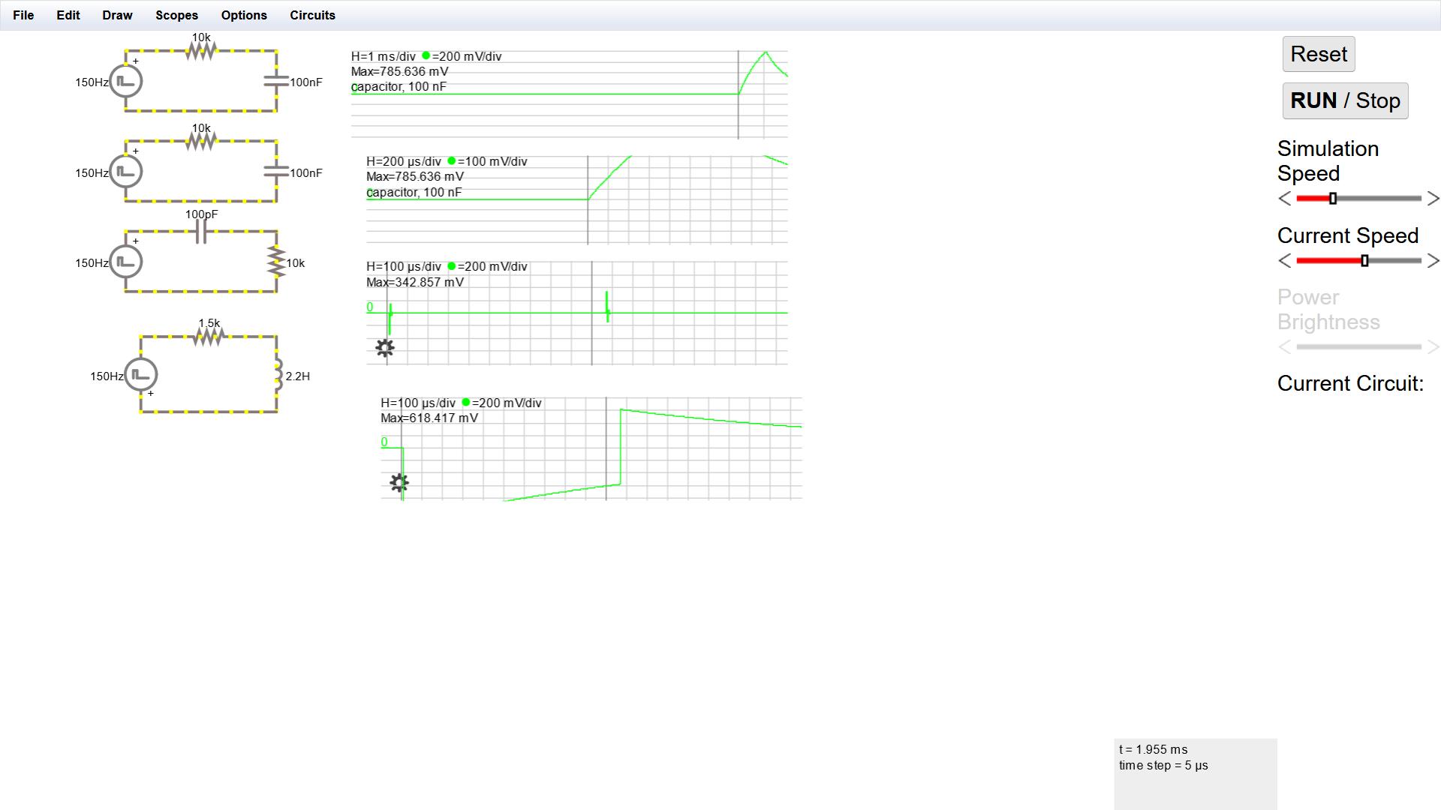

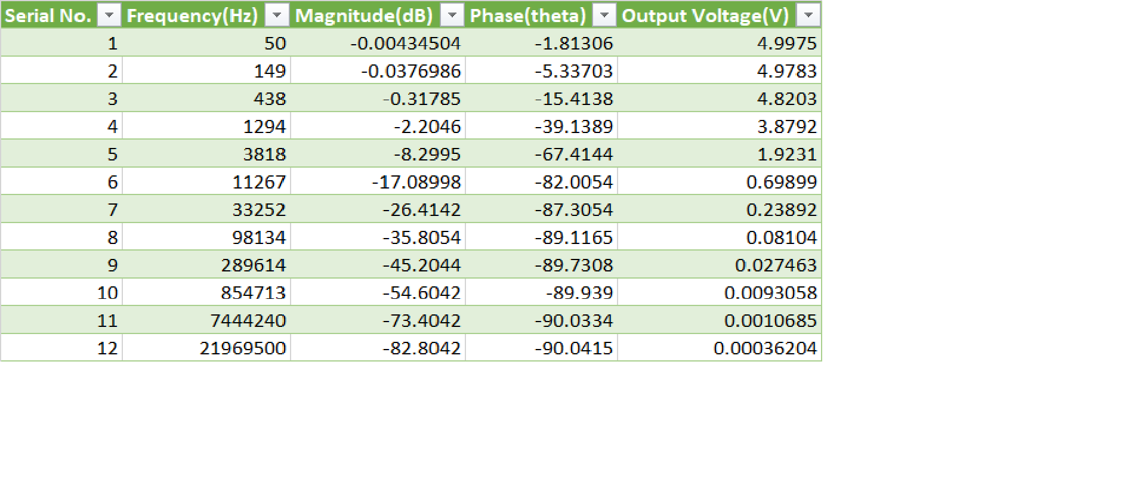**5.Measurement Data (Tabular form)**

|  |  |  |  |  |
| --- | --- | --- | --- | --- |
| **SRNo** | **RL** | **XL** | **VL(oscilloscope)** | **Calculated VL** |
| **1** | **infinity** | **infinity** | **2** | **1.78** |
| **2** | **2.15** | **2.15** | **1.25** | **1.123** |
| **3** | **1** | **1** | **0.83** | **0.77** |
| **4** | **0.6825** | **0.6825** | **0.63** | **0.7** |

Low Pass Filter

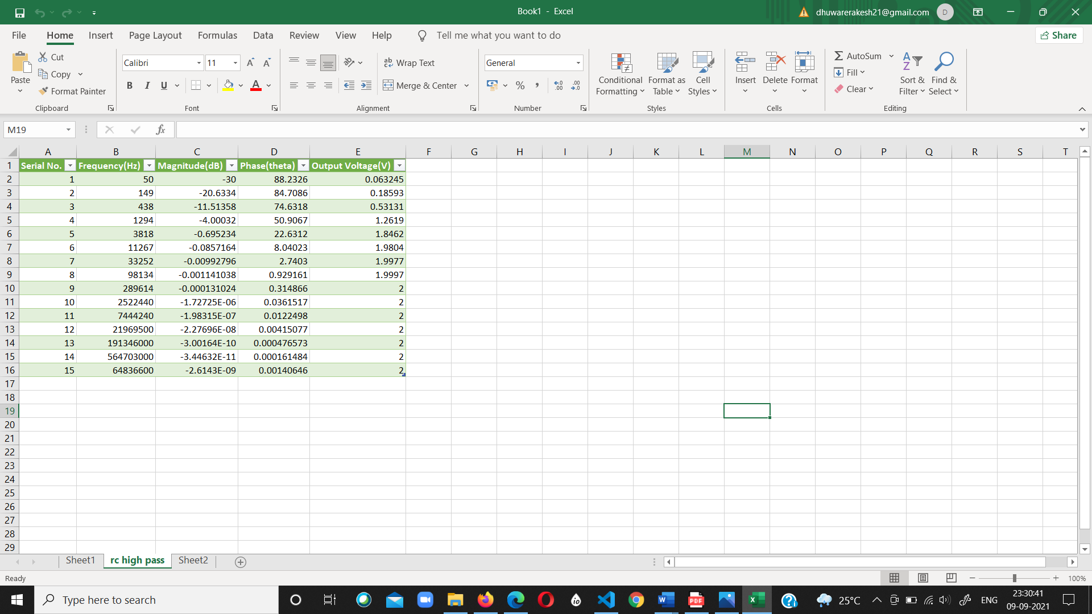

High Pass Filter

**6.Graph (Image)/Screenshots**

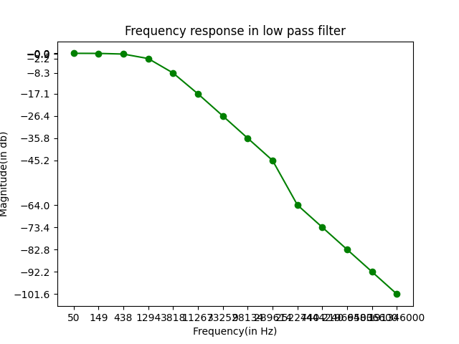

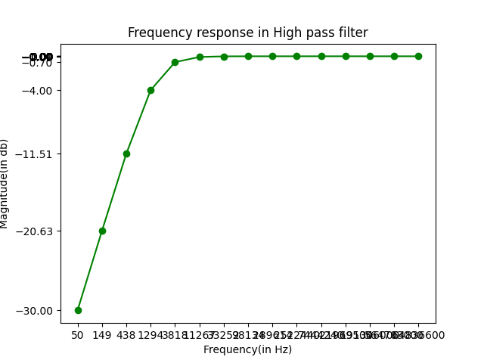

**7.Conclusion**

Voltage Divider(expt1)

Vout=Vin(R2/R1+R2)

= 10(20/20+10)

= 6.67 V which can be seen in the voltage divider circuit diagram.

RC HPF

From graph the cutoff frequency comes out to be ~8111Hz

While calculated frequency is ~7922Hz

Error = 2.4%

RC LPF

From graph the cutoff frequency comes out to be ~1520KHz

While calculated frequency is ~1592KHz

Error = 4.5%

**8.Discussions**

* A RC LPF acts as an integrator. It integrates the input signal into triangular waveforms(ideal).
* A RC HPF acts as a differentiator. It differentiates the input signal into frequency spikes. Vo decreases as capacitor charges
* A RL HPF acts as a differentiator also. It differentiates the input signal into frequency spikes. Vo decreases as steady stage is reached.
* The -3dB point is also known as the half-power points since the output power at this corner frequencies will be half that of its maximum 0dB value as shown above
* These -3dB corner frequency points define the frequency at which the output gain is reduced to 70.71% of its maximum value. Then we can correctly say that the -3dB point is also the frequency at which the systems gain has reduced to 0.707 of its maximum value.